**Lab 4: ES50 Section 007, Lombardo Thursday 6:30 pm – 9:30 pm**

**Name: Nabib Ahmed, Sharanya Pulapura, Andrew Jiang**

**3: LED Characteristics:**

b) 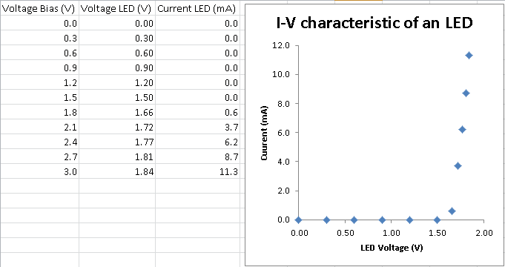

i) At 1.8 V from the source, the current of the LED starts dramatically increasing. At this voltage, the voltage across the LED is 1.66 V.

ii) At 1.8 V from the source (1.66 V across the LED), the LED started to emit light. This value is the same as in part i).

**4: Transmitter**

a)

i) The amplitude is 1.6 V when the LED turns on. Our voltage is significantly bigger than the amplitude of a music signal at the output of a portable music player.

ii) LED can give off light even when it’s negative.

iii) At 38Hz, we can longer see flickering of the LED.

b)

i) Drawing on separate paper

ii) Our linear regime is 1.5-1.75 volts. In order to maximize the AC voltage, our DC voltage should be at the center of the linear regime, maximizing the amount the AC source can add or subtract from the DC voltage while remaining in the linear regime. Based on our experimental data, we chose 1.625 volts for the DC source.

c)

i) The DC current and going through the AC voltage source is zero. When the AC source is at a low frequency, the capacitor behaves like an open circuit. The purpose of the capacitor is a high pass filter because the low frequencies cannot pass through the capacitor.

ii) The capacitor acts as a short when the AC source has very high frequency. Calculation shown on drawing (159 Hz). As stated above, this is a high pass filter.

vi) We increased the DC voltage to 2.2 V such that the Led voltage reached the middle of the linear range.

**5: Receiver**

a) The data sheet says that the photo-transistor is sensitive through visible and infrared light, so it can respond to red light. Pin 1 is emitter, 2 is base, and ][3 is collector.

b)

ii) The capacitor acts as a high pass filter.

c) When the bias is too small, clipping occurs because the amplitude of the signal exceeds the bias.